Create Policies with ORM Stack

Contents

1. Introduction 1
2. Workflow diagram to deploy the stack 1
3. Create stack for Policies on “Default Domain” 2
4. Plan the Job 15
5. Apply the Job 16
6. Verify in the Console 18
7. Destroy the stack (if required) 18

Introduction

This resource provides the Policy resource in OCI Identity service. It creates a new policy in the specified compartment, either the tenancy or another of your compartments. Need to specify a name for the policy, which must be unique across all policies in the tenancy and cannot be changed. For more than one policy statements, need to specify in the array.

Workflow diagram to deploy the stack

Below diagram shows how the Terraform Artifact are applied in the OCI. While creating a ORM stack, using terraform deliverables Init, Plan and Apply is the flow to provision the resource in the OCI. We can have the deliverables in any of below.
- GitLab/GitHub Repo
- Bitbucket
- Can be in folder/.zip in the local disk
- Object Storage Bucket
- Can be in compartment
- Oracle provided Template


Create stack for Policies on “Default Domain”

Go to OCI Console Developer Services Resource Manager Stacks select the compartment Create Stack

My Configuration Folder Browse Select the “Policy” folder that contains the artifacts Upload

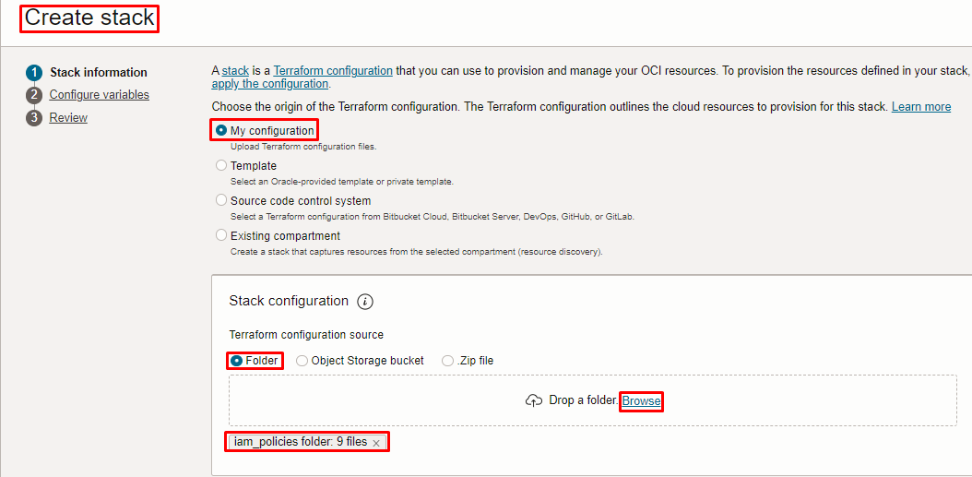
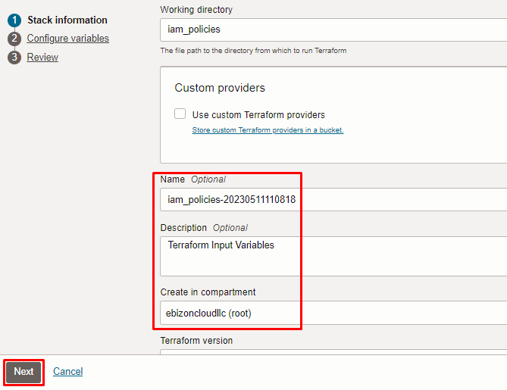

Click “NEXT”

Select the parameters as per the below screen,

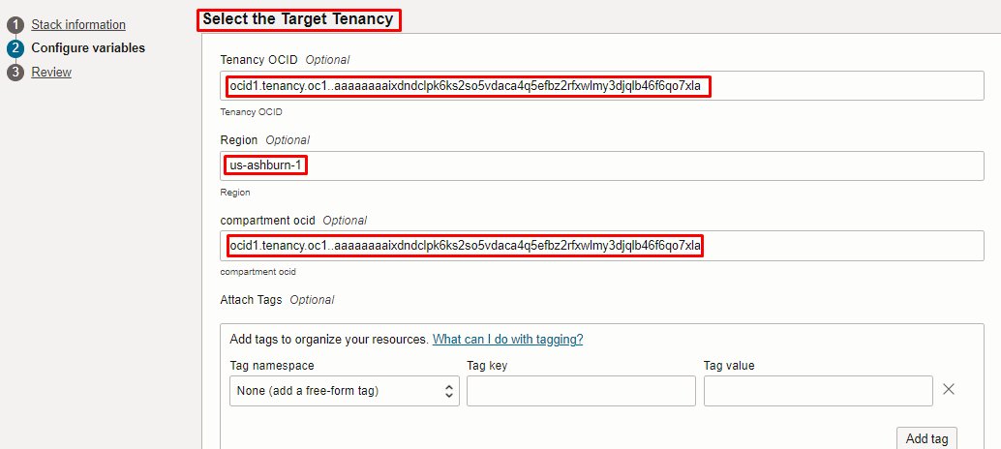
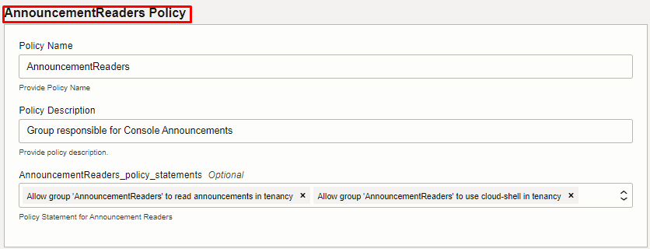
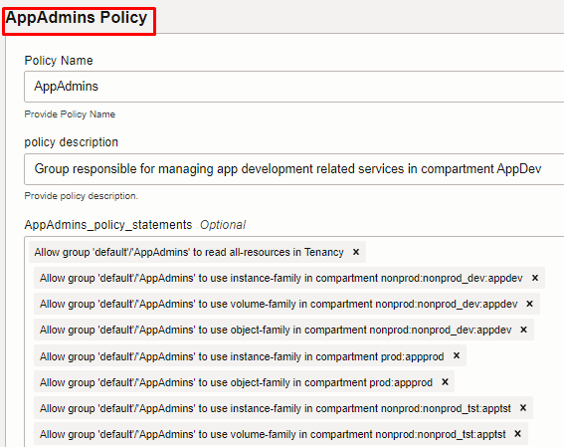
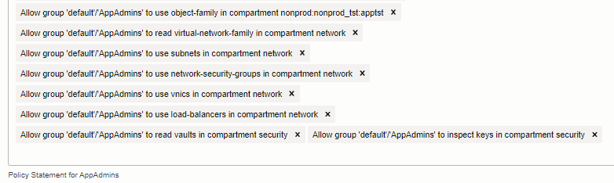
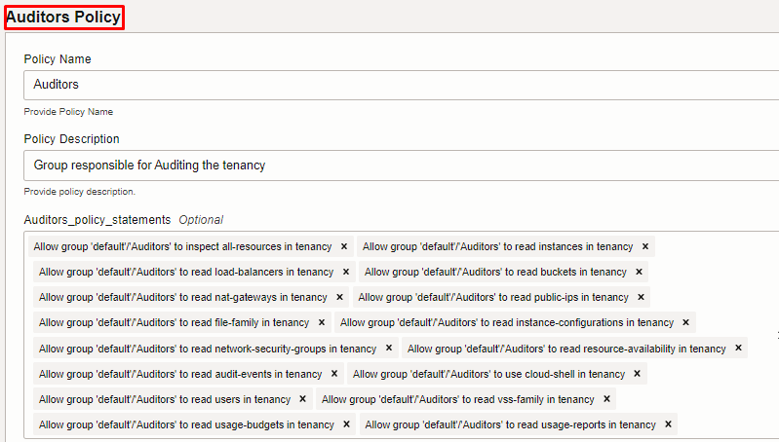
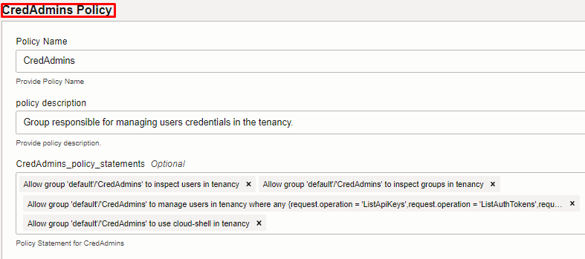
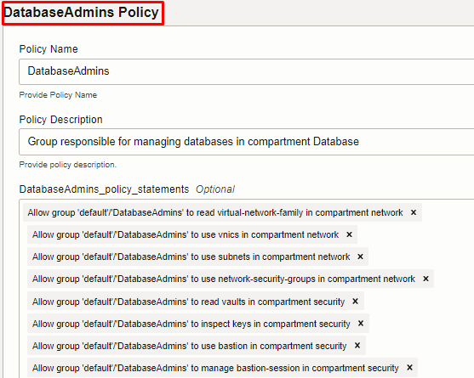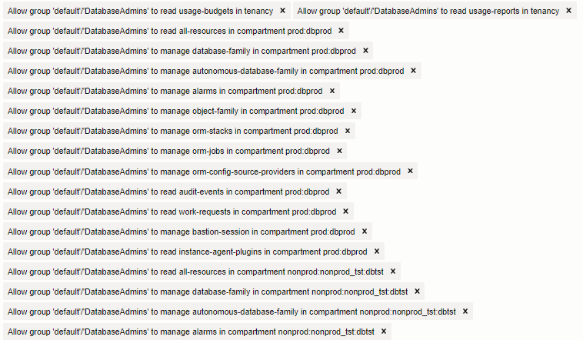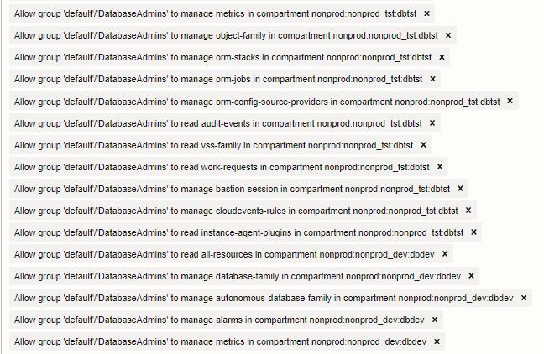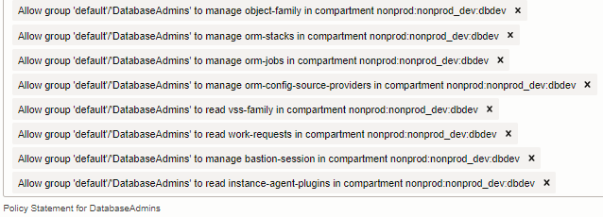

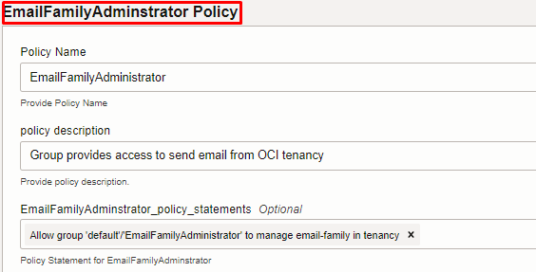
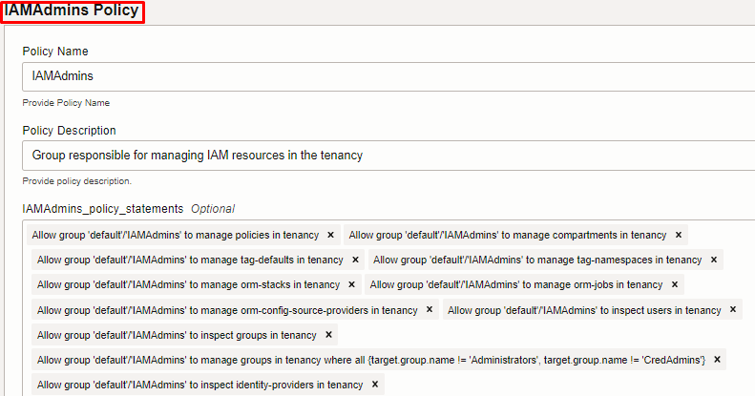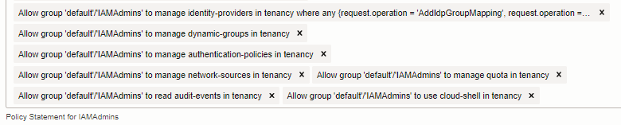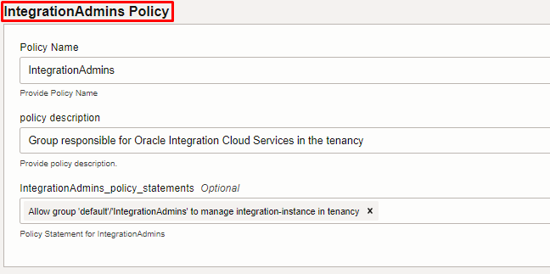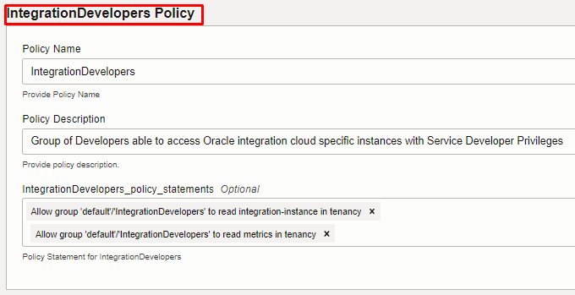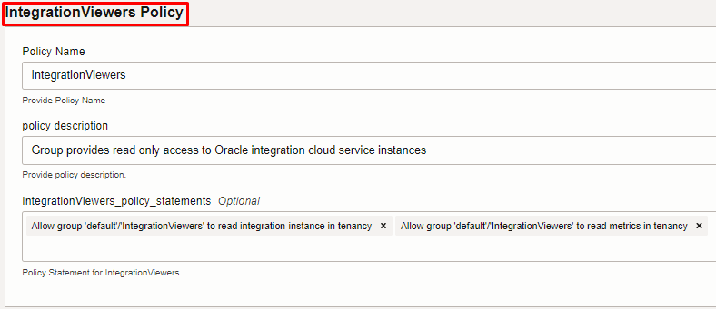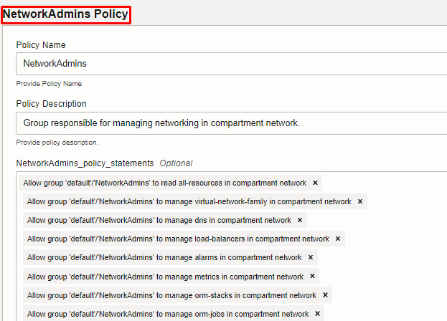
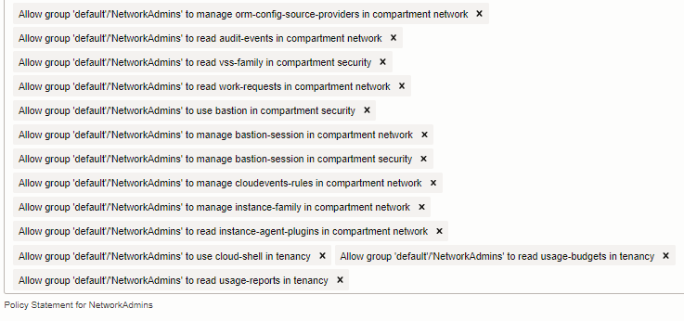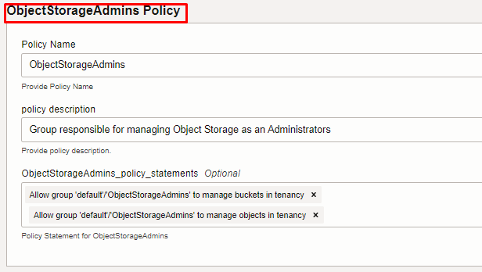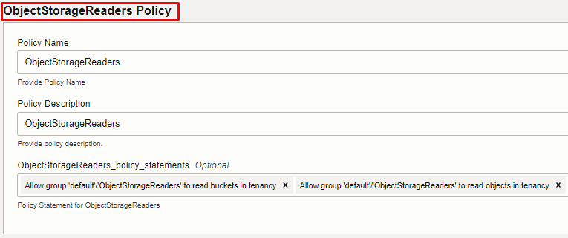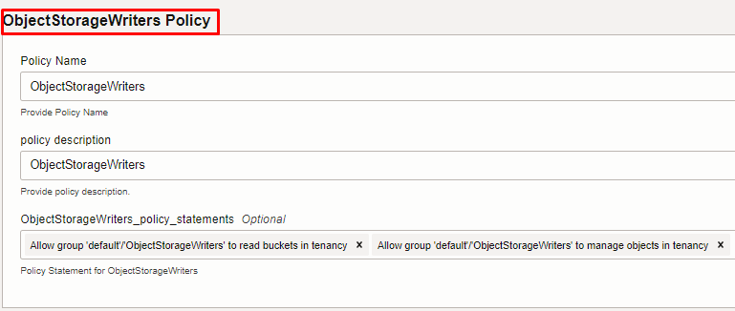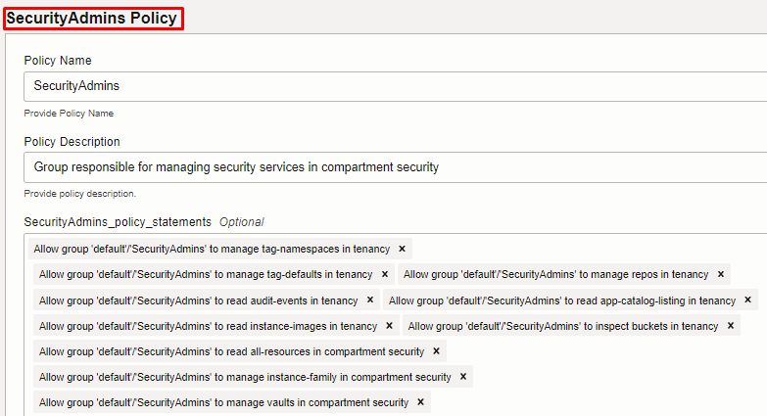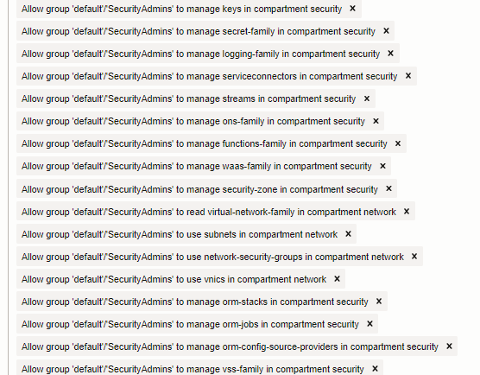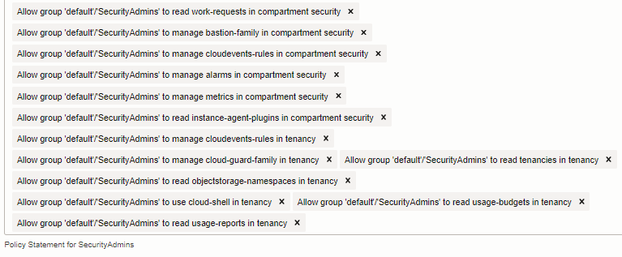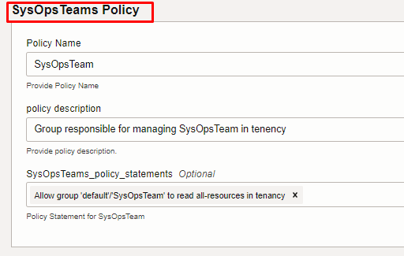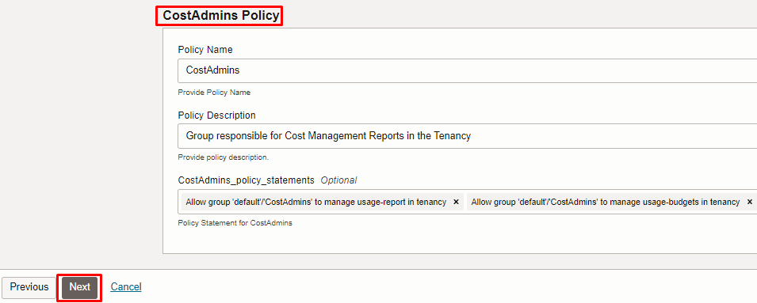

Note: select the right compartment to apply the stack in the OCI

Click “NEXT” Click “CREATE”
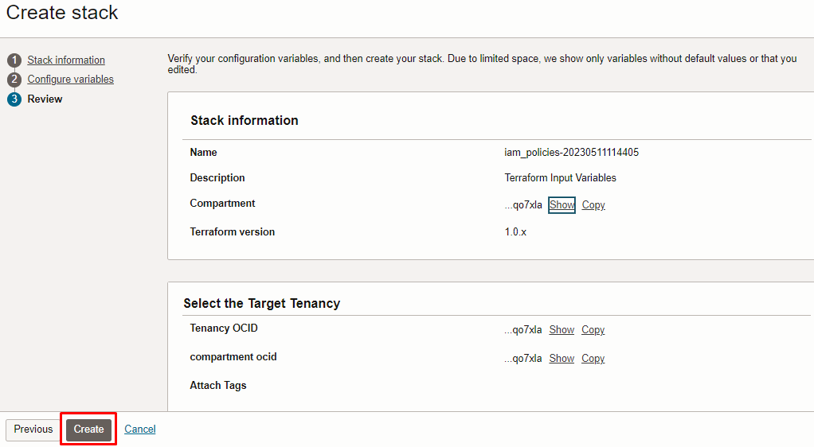

Plan the Job

Click the “Plan”

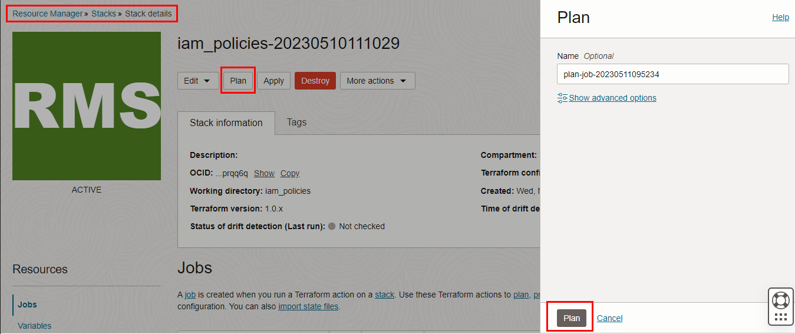

Verify the Plan is successful.

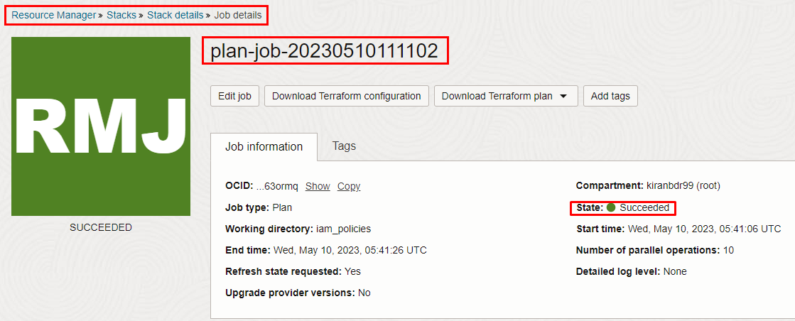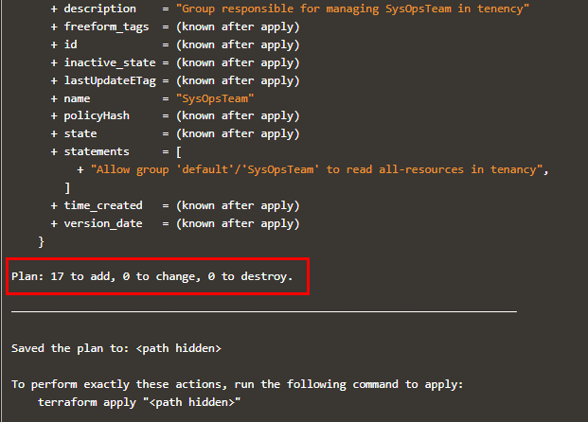

Apply the Job

Once the “plan” is success, now click “Apply”

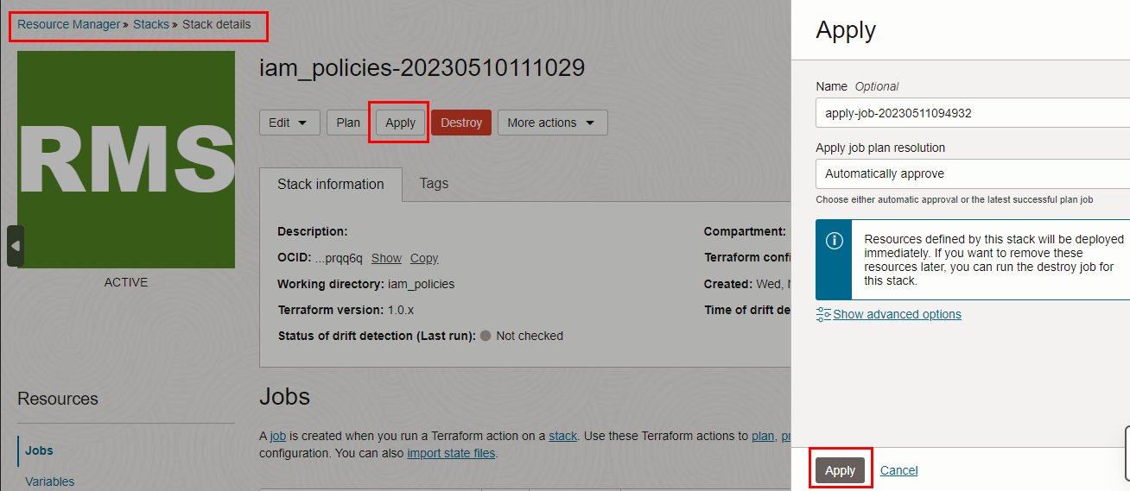

Verify the Apply is successful.

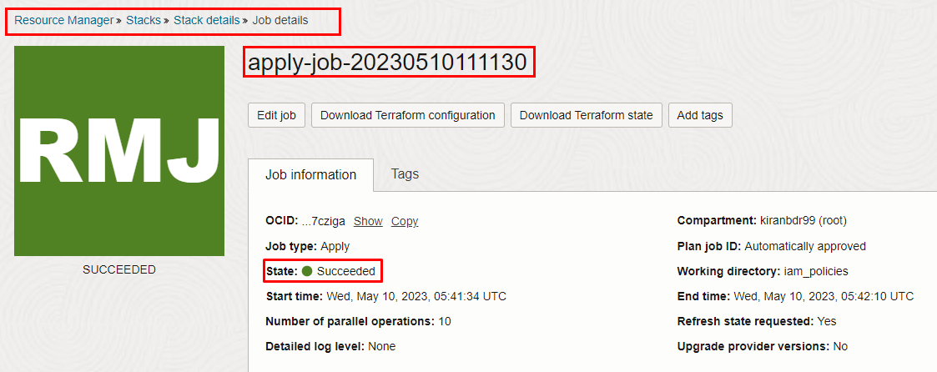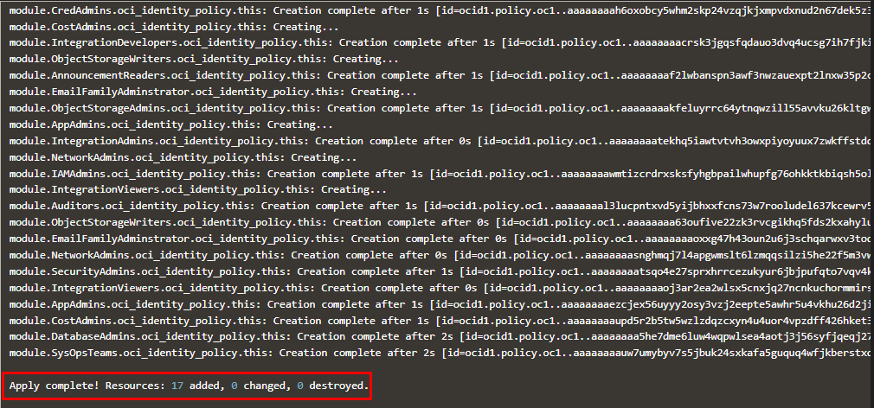

Verify in the Console

Go to OCI Console Identity & Security Policies
Note: Select the specified compartment (in the step 2) to get the output.

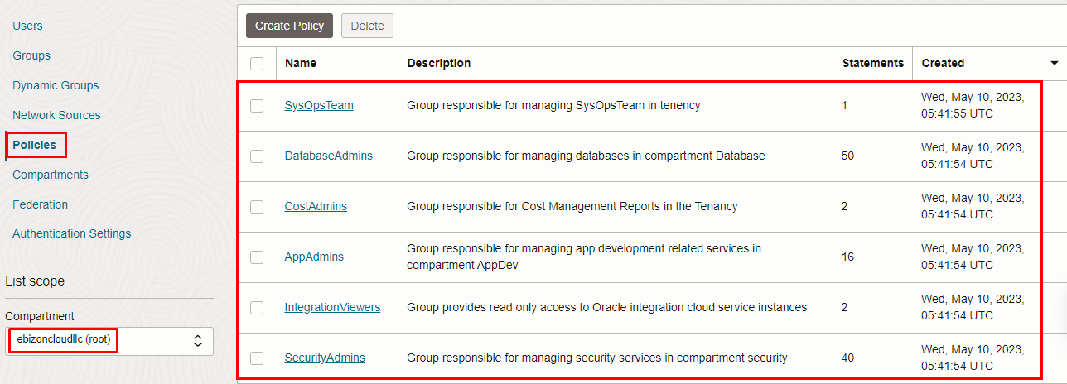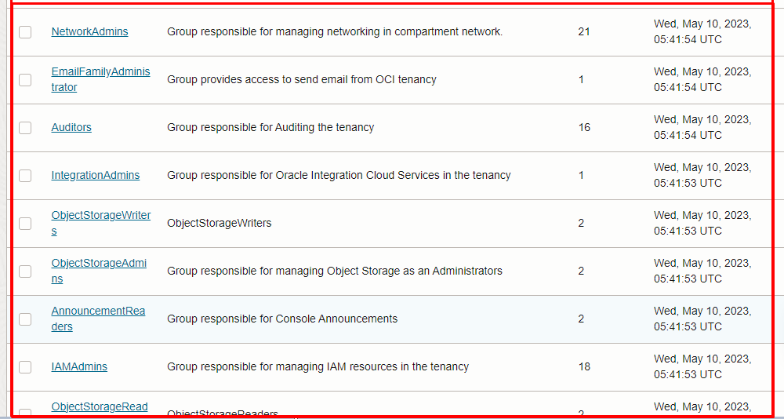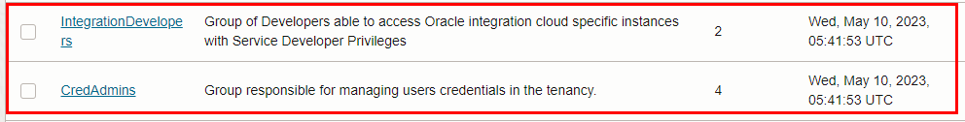

Destroy the stack (if required)

Create a destroy job in Resource Manager to release resources associated with a stack and clean up the tenancy. Once destroyed data cannot be recovered from resources.

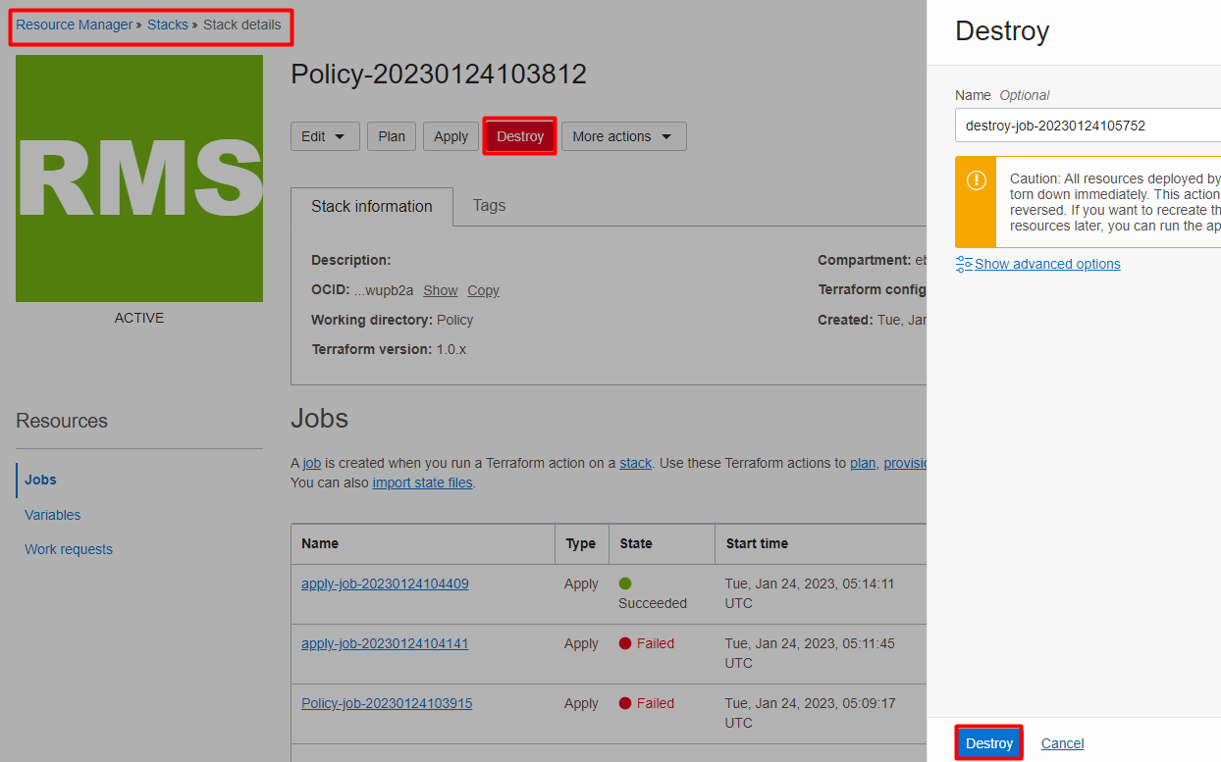

# END #

